IMPACT AWARD NOMINATION FORM

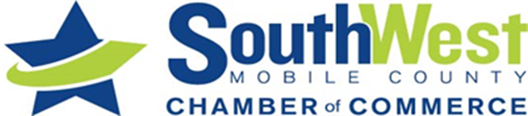
In choosing the recipient of the SouthWest Mobile County Chamber of Commerce Community Impact Award, regard is given to the nominee's achievements in the year immediately prior to receiving the award. As well as their past achievements and ongoing contribution to the community. We will honor the recipient at an award banquet and recognize their achievements for dedication to community service.

The Impact Award was started last year to recognize a company that strives to make our Community a better place. A Company who among other things, makes continuing efforts in the community for improvement, involvement with local charity/non-profit projects, making safety and environmental issues a priority. Maintains an excellent employment history as well as having employee quality and longevity. The Impact Award is to be given to a Company who is proven to be a good steward in the community and is dedicated to the march in giving back as well as becoming a leader in industry here in Mobile.

ACHIEVEMENT AND NATURE OF SERVICE:
Please explain in your own words on a separate sheet of paper, how this nominee would be worthy of our recognition.

1) Contributions to the welfare and betterment of the community.
2) Evidence of lasting contribution to the community and the impact they bring to others.
3) Participation in community activities and civic enterprises.
4) Evidence of staff sustainability and business progress
5) Cooperation with individuals and civic organizations.

RULES & ELIGIBLITY:
1) Award will be conferred for achievements, leadership and service to the community.
2) Nominations must be in the Chamber of Commerce Office by September 23rd, 2022. They must be in writing and signed by the individual or group making the nomination. Sealed in an envelope marked “Impact Award”, they will be held in the strictest of confidence.
3) Selection will be made by a committee.

I nominate the following Company:
Name: ________________________________________________________ Phone: _________________________
Address: ______________________________________________________________________________________
Email: ________________________________________________________________________________________
My information:
Name: _____________________________________________________ Phone: ____________________________
Address: ______________________________________________________________________________________
Business (if applicaple):__________________________________email:___________________________________
Are you a Chamber Member? Yes________ No_________
Did you attach a letter of support with this nomination form? Yes _______ No________
Return all materials via email or postal mail to:
SouthWest Mobile County Chamber of Commerce - 5055 Carol Plantation Road | Mobile, AL 36619
Phone: (251) 666-2488 Email: info@swmcchamber.com

